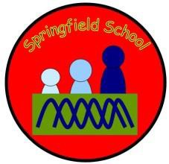

SPRINGFIELD SCHOOL

Charging and Remissions Policy

Aim

It is our aim to provide as many opportunities for Springfield pupils to enrich and extend their learning experiences. This may include activities both on and off site.

Voluntary contributions

- When organising school trips or visits to broaden the educational experiences of the children and/or to enrich the curriculum, the school invites parents to contribute to the cost of the trip. All contributions are voluntary. If insufficient money is raised from parental contributions, a visit or activity may need to be cancelled. Where a trip does go ahead, this may include children whose parents have not made any contribution. We do not treat these children differently from any others.

- If a parent is unwilling or unable to make a contribution, no child is excluded from taking part in any trip or activity. The school will pay any additional costs to support the visit. Parents have a right to know how each trip is funded. The school provides this information on request.

- The school will not make any charges which seek to make a profit.

- The following list details some of the activities organised by the school that require voluntary contributions from parents. This list is not exhaustive.

  - School trips
  - Sporting activities
  - Outdoor adventure activities
  - Visits to museums
  - Theatre visits

Chair of Governors | Darryl Davies
Executive Headteacher | Chris Best
Date for review | May 2025

AA/Charges & Remission Policy 1

