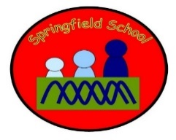 Badgers Class Medium Term Planning for PSHE Spring Term 1 2024
Topic: Seas and Oceans  Subject area – Respectful relationships  The world I live in  Taking care of the environment | This topic will be continually developed throughout the curriculum every day. There will be frequent opportunities to make choices using speech and AAC and to develop play, friendships, helping and co-operation.  This half-term PHSE will be taught through Geography – Keeping our rivers and seas clean, Science - environments, IEP targets and throughout the day, class rules – Kind hands, feet and words.

Friendships – re-introduce  Focus on class rules | Friendships – further development, taking turns, giving out equipment, approaching named people, saying names, class rules | Friendships – further development, taking turns, giving out equipment, approaching named people, saying names, class rules | Friendships – further development, taking turns, giving out equipment, approaching named people, saying names, class rules | Friendships – further development, taking turns, giving out equipment, approaching named people, saying names, class rules | Friendships – further development, taking turns, giving out equipment, approaching named people, saying names, class rules

