Our Anti-Bullying Booklet
Feeling Safe and Happy at School
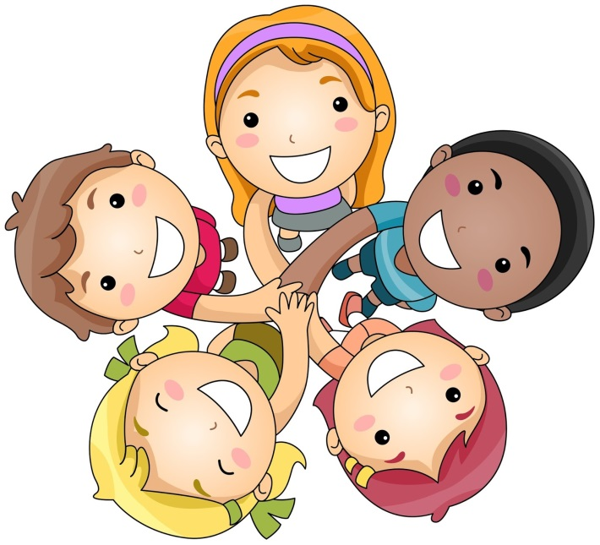

Feeling safe and happy at school

At Springfield School and The Meadows School we want to make sure that you feel looked after, safe and happy when you are in and out of school.

Sometimes we don’t know if something bad is happening, so you need to tell us.

This booklet looks at bullying, and what you can do when you feel you are being bullied, or when you notice someone else being bullied.

What is bullying?

“Bullying means a person or group of people doing nasty or unkind things to someone on purpose. This is meant to scare, hurt or upset that person. It happens more than just once. It can happen face to face or online.”

Bullying is…

Several Times On Purpose

Falling out with friends is not bullying.

Bullying is behaviour which is repeated on purpose and is meant to upset someone.

Types of Bullying
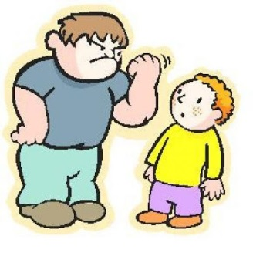

- Hitting or saying you are go to hit someone (Physical)
- Touching someone when they don’t want you to
- Calling someone names, teasing, or using rude words (Verbal)
- Taking or breaking someone elses things
- Leaving someone out or ignoring them (Emotional)
- Sending unkind messages over the internet or message (Cyber)

What can I do if I am being bullied?

- Tell the bully to stop.
- Tell a grown-up, such as your parent, carer or teacher.
- Tell a good friend
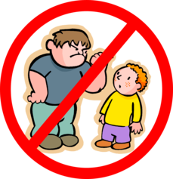
- Write a note for a grown up
- Call Child Line on 0800 1111
Always remember, it is not your fault and you are never alone.

If you talk to a grown-up, we can make the bullying stop.
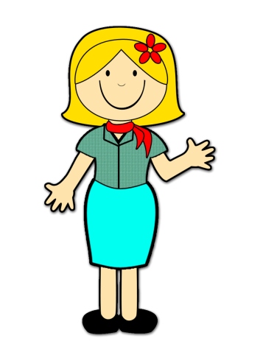
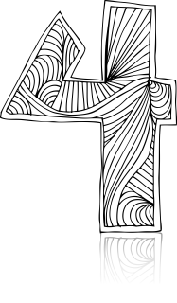

What should I do if I see someone else being bullied?

Tell a grown-up, such as a teacher, as soon as you’ve seen someone being bullied.

Grown-ups can stop the bullying and make that person feel happy again.

You should never feel scared to tell someone about bullying.

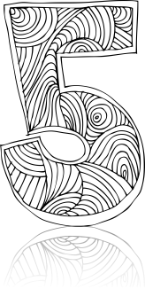
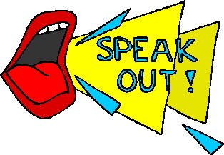
Who can I talk to?

It is important that you tell someone as soon as you are being bullied, or you notice someone else being bullied.

Speaking to someone like your mum, dad, carer or teacher will mean that we can make sure the bullying stops and doesn’t happen again.

Is something worrying you?

Talk to your teacher or any grown up or find one of us:

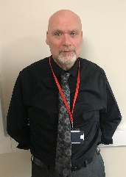

Kieron Sarah Lauren

How can I help to stop bullying?
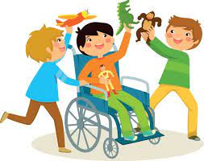
- Making sure we follow the school rules.
- Help others.
- Being kind and friendly to others.
- Letting others join in our games.

